Environment Setup for Satellite Server Installation
Before installing Red Hat Satellite Server, ensure your system meets these prerequisites.
1. System Details
- Operating System: RHEL 9
- Storage: 500 GB
- RAM: 34 GB
- CPU: 4 cores
- Hostname: Satellite-pd.example.com
- Subscription: Active Red Hat Satellite subscription
- Access: Root/admin
- DNS: Full forward and reverse resolution must work.
- Environment: Must install on a clean system with no other functions or conflicting users (like apache, postgres, pulp, redis, etc.).
- SELinux: Enabled (enforcing or permissive).
- Time Sync: System clock synchronized (e.g., using Chrony) to avoid SSL issues.
- FIPS Mode: Satellite supports DEFAULT and FIPS cryptographic policies, but FUTURE policy is not supported.

2. Storage Requirements
Directory | Installation | Runtime
/var/log | 10 MB | 10 GB
/var/lib/pgsql | 100 MB | 20 GB
/usr | 10 GB | N/A
/opt/puppetlabs | 500 MB | N/A
/var/lib/pulp | 1 MB | 300 GB
Guidelines:
- Mount /var on LVM for scalability.
- Use fast, low-latency storage for /var/lib/pulp and /var/lib/pgsql.
- /tmp must allow execution (exec) for Puppet.
- Avoid symbolic links for /var/lib/pulp.
- Manage logs using logrotate.
- For NFS mounts, set proper SELinux context to avoid blocks.
3. Supported Systems and Browsers
- Supported OS: Latest RHEL 9 (x86_64) only.
- Satellite must run on a dedicated system; no extra software.
- Supported browsers for UI: Firefox and Google Chrome.
- Supported languages: English, French, Japanese, Korean, Simplified Chinese.

4. Network and Firewall Requirements
Incoming Ports (Server):
  - 53 TCP/UDP – DNS
  - 443 TCP – HTTPS API and content sync
  - 80 TCP – HTTP for registration
  - 5910–5930 TCP – Browser console
  - 8000 TCP – PXE/HTTP templates
  - 9090 TCP – OpenSCAP, REX, Capsule API
Outgoing Ports (Server):
  - 22 TCP – SSH for remote execution
  - 53 TCP/UDP – DNS resolution
  - 80/443 TCP – Content and repository sync
Use firewall-cmd to open required ports and make persistent.

Setting up the environment

Set the Hostname
We set a proper name for the server so it can be identified on the network.
[root@satellite-pd ~]# hostnamectl set-hostname satellite-pd.example.com

Verify the hostname:
[root@satellite-pd ~]# hostnamectl
Static hostname: satellite-pd.example.com
Icon name: computer-vm
Chassis: vm 🖴
Machine ID: *******************************
Boot ID: *******************************
Virtualization: vmware
Operating System: Red Hat Enterprise Linux 9.6 (Plow)
CPE OS Name: cpe:/o:redhat:enterprise_linux:9::baseos
Kernel: Linux 5.14.0-427.13.1.el9_4.x86_64
Architecture: x86-64
Firmware Version: VMW20

Partition Setup (LVM)

Check Current Disks
- lsblk to check
[root@localhost ~]# lsblk
NAME MAJ:MIN RM SIZE RO TYPE MOUNTPOINTS
sda 8:0 0 500G 0 disk
├─sda1 8:1 0 600M 0 part /boot/efi
├─sda2 8:2 0 1G 0 part /boot
└─sda3 8:3 0 498.4G 0 part
├─rhel-root 253:0 0 70G 0 lvm /
├─rhel-swap 253:1 0 16.7G 0 lvm [SWAP]
└─rhel-home 253:2 0 50G 0 lvm /home
sr0 11:0 1 1024M 0 rom

We created the following LVs:
- lv_log—Logs for Satellite
- lv_pupl—Content storage (Pulp)
- lv_pgsql—PostgreSQL database
- lv_tmp—Temporary files (/tmp)
- lv_puppet—Puppet data
- Home,usr and root already set with sufficient space and separate lv

Commands Used
- Creating lv
[root@localhost ~]# lvcreate -L 30G -n lv_pulp rhel
Logical volume "lv_pulp" created.

- Creating filesystem
[root@localhost ~]# mkfs /dev/rhel/lv_pulp
mke2fs 1.46.5 (30-Dec-2021)
Discarding device blocks: done
Creating filesystem with 7864320 4k blocks and 1966080 inodes
Filesystem UUID: e873f35a-5044-41f7-b675-d148a9e9f218
Superblock backups stored on blocks:
32768, 98304, 163840, 229376, 294912, 819200, 884736, 1605632, 2654208,
4096000
Allocating group tables: done
Writing inode tables: ^C5/240

- Creating mount point
[root@localhost ~]# mkdir -p /var/lib/pulp

- Mounting permanent
[root@localhost ~]# vim /etc/fstab

UUID="************" /var/lib/pulp xfs defaults 0 0

- Reload the daemon and mount -a
[root@localhost ~]# systemctl daemon-reload
[root@localhost ~]# mount -a

We repeated similar steps for lv_pulp, lv_log, lv_tmp, lv_puppet, and home with their respective directories.
Final partition

[root@satellite-pd ~]# lsblk
NAME MAJ:MIN RM SIZE RO TYPE MOUNTPOINTS
sda 8:0 0 500G 0 disk
├─sda1 8:1 0 600M 0 part /boot/efi
├─sda2 8:2 0 1G 0 part /boot
└─sda3 8:3 0 498.4G 0 part
├─rhel-root 253:0 0 70G 0 lvm /
├─rhel-swap 253:1 0 16.7G 0 lvm [SWAP]
├─rhel-home 253:2 0 50G 0 lvm /home
├─rhel-lv_pulp 253:3 0 30G 0 lvm /var/lib/pulp
├─rhel-lv_pgsql 253:4 0 20G 0 lvm /var/lib/pgsql
├─rhel-lv_log 253:5 0 10G 0 lvm /var/log
├─rhel-lv_tmp 253:6 0 20G 0 lvm /tmp
└─rhel-lv_puppet 253:7 0 1G 0 lvm /opt/puppetlabs
sr0 11:0 1 1024M 0 rom

lvs

[root@satellite-pd ~]# lvs
home rhel -wi-ao---- 50.00g
lv_log rhel -wi-ao---- 10.00g
lv_pgsql rhel -wi-ao---- 20.00g
lv_pulp rhel -wi-ao---- 30.00g
lv_puppet rhel -wi-ao---- 1.00g
lv_tmp rhel -wi-ao---- 20.00g
root rhel -wi-ao---- 70.00g
swap rhel -wi-ao---- <16.70g
DNS Server Setup

Install DNS (BIND)

[root@satellite-pd ~]# yum install bind bind-utils -y

Enable and start service

[root@satellite-pd ~]# systemctl enable named.service
Created symlink /etc/systemd/system/multi-user.target.wants/named.service → /usr/lib/systemd/system/named.service.
[root@satellite-pd ~]# systemctl start named
[root@satellite-pd ~]# systemctl status named

Firewall rules setting

[root@satellite-pd ~]# firewall-cmd --add-service=dns --permanent
success
[root@satellite-pd ~]# firewall-cmd --add-port=53/tcp --permanent
success
[root@satellite-pd ~]# firewall-cmd --add-port=53/udp --permanent
success

Configure main dns file

[root@satellite-pd ~]# vim /etc/named.conf

listen-on port 53 { 127.0.0.1;<ip>; };
allow-query { localhost; 192.168.0.0/16; any; };

//add zones
zone "example.com" IN {
type master;
file "forward.zone";
};
zone "96.168.192.in-addr.arpa" IN {
type master;
file "reverse.zone";
};

Create forward zone file

[root@satellite-pd ~]# vim /var/named/forward.zone

$TTL 1D
@ IN SOA satellite-pd.example.com. admin.example.com. (
2025092901 ; serial
1H ; refresh
10M ; retry
1W ; expire
1D ) ; minimum
IN NS satellite-pd.example.com.
satellite-pd IN A 192.168.96.220

Create reverse zone file
[root@satellite-pd ~]# vim /var/named/reverse.zone
$TTL 1D
@ IN SOA satellite-pd.example.com. admin.pd.example.com. (
2025092902 ; serial (increment serial)
1H ; refresh
10M ; retry
1W ; expire
1D ) ; minimum
IN NS satellite-pd.example.com.
; PTR record for reverse lookup
220 IN PTR satellite-pd.example.com.

Add Nameserver to /etc/resolv.conf
- Note for persistent do it in nmtui in dns place add the ip of our dns server

[root@satellite-pd ~]# vim /etc/resolv.conf
search example.com
nameserver 192.168.96.220 //add this
nameserver 8.8.8.8

Restart the service and test it
[root@satellite-pd ~]# systemctl restart named.service
[root@satellite-pd ~]# nslookup satellite-pd.example.com
Server: 192.168.96.220
Address: 192.168.96.220#53
Name: satellite-pd.example.com
Address: 192.168.96.220
[root@satellite-pd ~]# nslookup 192.168.96.220
220.96.168.192.in-addr.arpa name = satellite-pd.example.com.

Sync time with the network (NTP)

Install Chrony

[root@satellite-pd ~]# dnf install chrony -y

Enable and Start the Service

[root@satellite-pd ~]# systemctl enable chronyd --now
[root@satellite-pd ~]# systemctl status chronyd

Firewall and Services Configuration Documentation
This document explains the firewall configuration applied on the server, including incoming ports, outgoing ports, and services with commands and detailed explanations.
1. Incoming Ports Added
These are the ports opened for incoming traffic on the server:
Port | Protocol | Purpose | Explanation
448 | TCP | HTTPS for Pulp content delivery | Required for Satellite/Pulp to securely deliver content (RPM packages, metadata) to clients.
80 | TCP | HTTP(repos, capsule/puppet communication) | Enables standard web access for repositories, Capsule servers, and Puppet agent communications over HTTP.
53 | TCP/UDP | DNS (if server acts as DNS) | Used for resolving domain names. TCP is used for large queries like zone transfers, UDP for standard queries.
8000 | TCP | HTTP(custom Satellite service / capsule) | Used by Red Hat Satellite for custom Capsule service communication.
9090 | TCP | HTTPS(custom service / web UI) | Used for secure Satellite or application web interfaces (Cockpit or custom web UI).

Commands:
Add incoming ports permanently

firewall-cmd --permanent --add-port=448/tcp
firewall-cmd --permanent --add-port=80/tcp
firewall-cmd --permanent --add-port=53/tcp
firewall-cmd --permanent --add-port=53/udp
firewall-cmd --permanent --add-port=8000/tcp
firewall-cmd --permanent --add-port=9090/tcp

2. Outgoing Ports Added
These are the ports allowed for outgoing connections from the server:
Port | Protocol | Purpose | Explanation
22 | TCP | SSH(remote host management) | Allows the server to initiate SSH connections to other servers for remote administration and automation.
53 | TCP/UDP | DNS queries | Enables the server to query external DNS servers to resolve hostnames.
443 | TCP | HTTPS (Red Hat CDN, external repositories) | Required for connecting to Red Hat CDN, fetching updates, and accessing secure external repositories.
Commands:
Allow outgoing ports (example using rich rules if needed)

firewall-cmd --permanent --add-rich-rule='rule family="ipv4" port protocol="tcp" port="22" accept'
firewall-cmd --permanent --add-rich-rule='rule family="ipv4" port protocol="tcp" port="53" accept'
firewall-cmd --permanent --add-rich-rule='rule family="ipv4" port protocol="udp" port="53" accept'
firewall-cmd --permanent --add-rich-rule='rule family="ipv4" port protocol="tcp" port="443" accept'

3. Services Added
These are the services enabled in the firewall:
Service | Ports Used | Purpose | Explanation
DNS | 53/TCP, 53/UDP | Name resolution | Required when the server itself acts as a DNS resolver or authoritative DNS server.
DHCP | 67/UDP, 68/UDP | Dynamic host configuration | Allows the server to provide/receive IP addresses dynamically (PXE boot environments).
TFTP | 69/UDP | File transfer for PXE boot | Used for network booting (PXE clients download boot images from server).
HTTP | 80/TCP | Web services & repository access | Provides unencrypted web access and repository services for clients.
HTTPS | 443/TCP | Secure web services | Ensures encrypted communication for web services, CDN access, and repositories.
Puppet Master | 8140/TCP | Puppet agent communication | Puppet agents use this port to connect to Puppet Master for configuration management.
Commands:
# Add services permanently
firewall-cmd --permanent --add-service=dns
firewall-cmd --permanent --add-service=dhcp
firewall-cmd --permanent --add-service=tftp
firewall-cmd --permanent --add-service=http
firewall-cmd --permanent --add-service=https

Puppet is not a default firewalld service, so add by port

firewall-cmd --permanent --add-port=8140/tcp

4. Apply Changes
Once all ports and services are added, reload the firewall:
firewall-cmd --reload
To verify the applied rules and services:
firewall-cmd --list-all
Summary
- Incoming ports: Opened to allow clients and services to communicate with this server.
- Outgoing ports: Enabled so the server can reach external repositories, DNS servers, and remote hosts.
- Services: Added to support network services (DNS, DHCP, TFTP, HTTP/HTTPS, Puppet).
This ensures the system can act as a Satellite/management server, provide DNS/DHCP/TFTP services, and securely fetch updates and content.

Installing Satellite

Registering to Red Hat Subscription Management

[root@satellite-pd ~] subscription-manager register
Username: user_name
Password:

Configuring repositories

Disable all repositories:
[root@satellite-pd ~]# subscription-manager repos --disable "*"

Enable the following repositories:

[root@satellite-pd ~]# subscription-manager repos \
--enable=rhel-9-for-x86_64-baseos-rpms \
--enable=rhel-9-for-x86_64-appstream-rpms \
--enable=satellite-6.17-for-rhel-9-x86_64-rpms \
--enable=satellite-maintenance-6.17-for-rhel-9-x86_64-rpms

Verification

[root@satellite-pd ~]# dnf repolist enabled

Installing Satellite Server packages

[root@satellite-pd ~]# dnf upgrade
[root@satellite-pd ~]# dnf install satellite

Configuring Satellite installation

[root@satellite-pd ~]# satellite-installer --scenario satellite \
--foreman-initial-organization "My_Organization" \
--foreman-initial-location "My_Location" \
--foreman-initial-admin-username admin_user_name \
--foreman-initial-admin-password admin_password

Importing a Red Hat subscription manifest into Satellite Server
- Log in to Red Hat Customer Portal
- Navigate to Subscription Allocation
- Create a New Allocation
- Give in name, satellite version
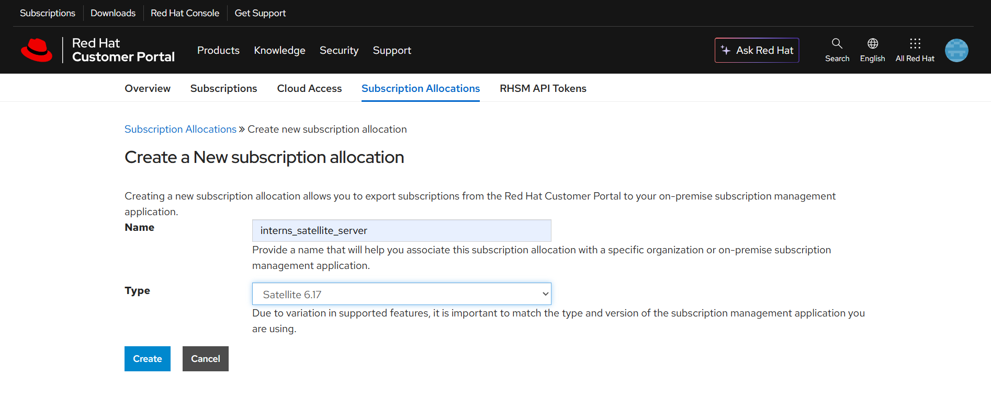
- Select subscription and download the manifest file
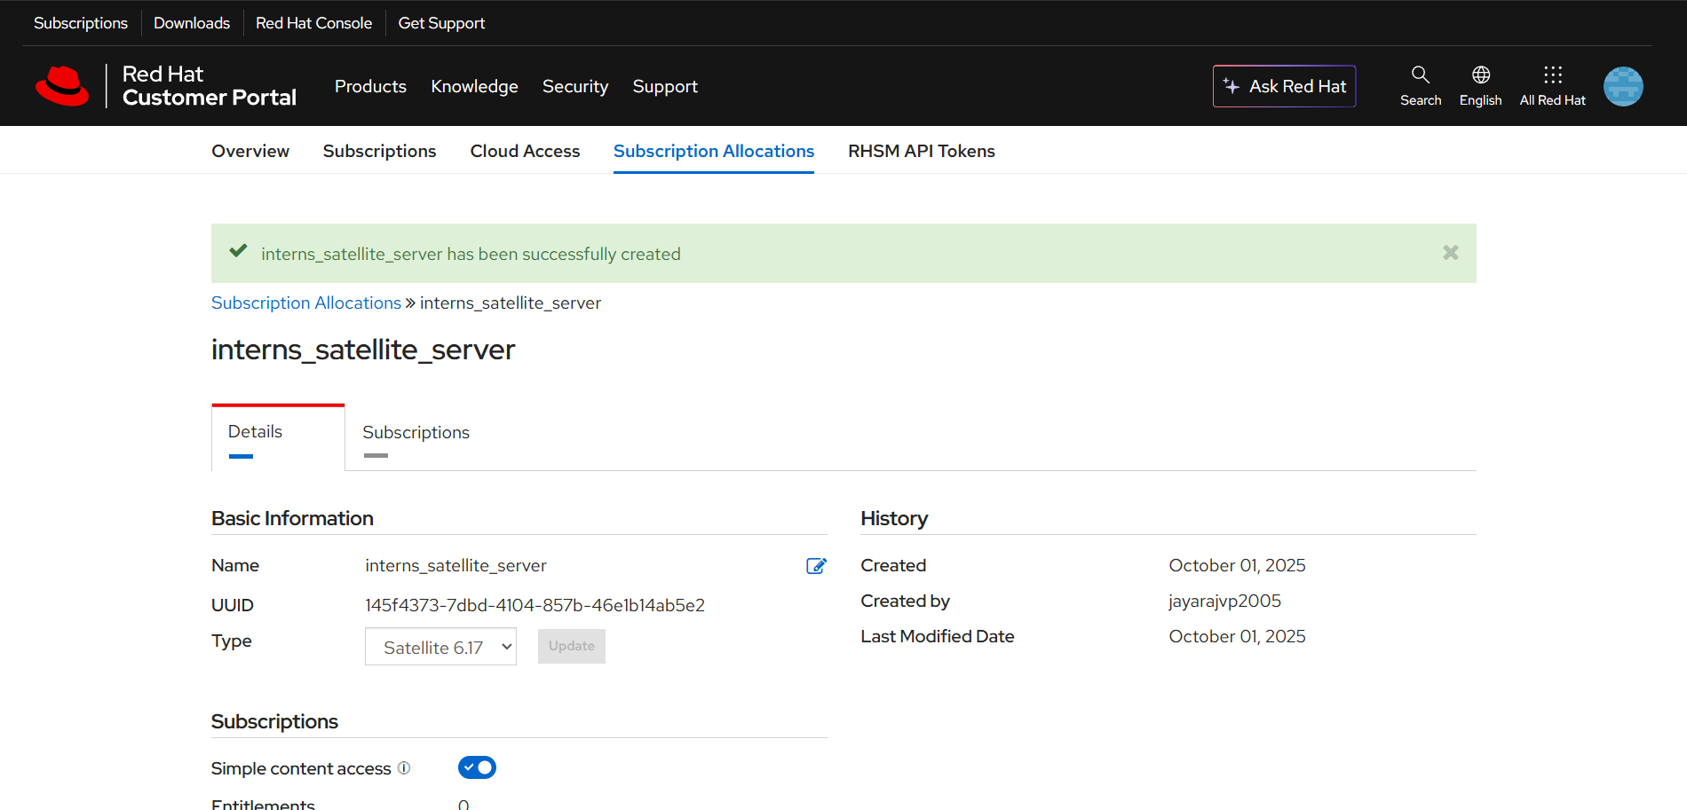
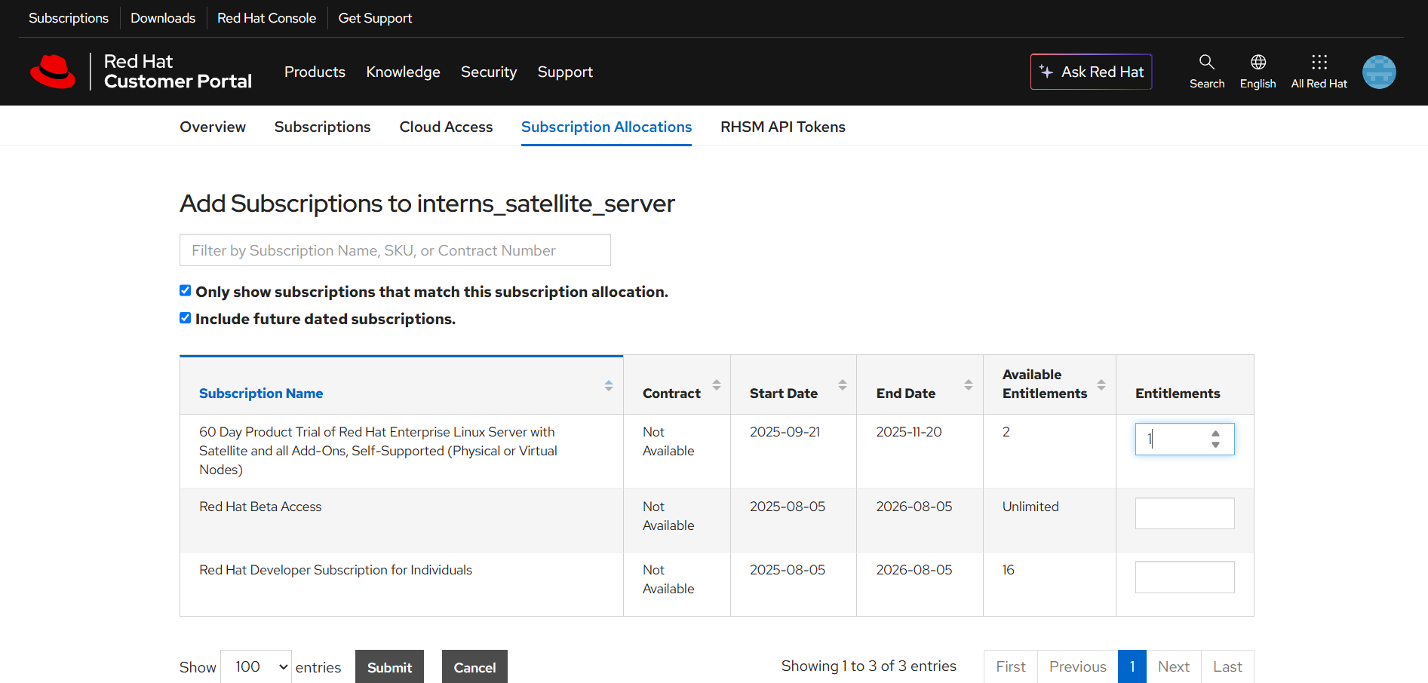
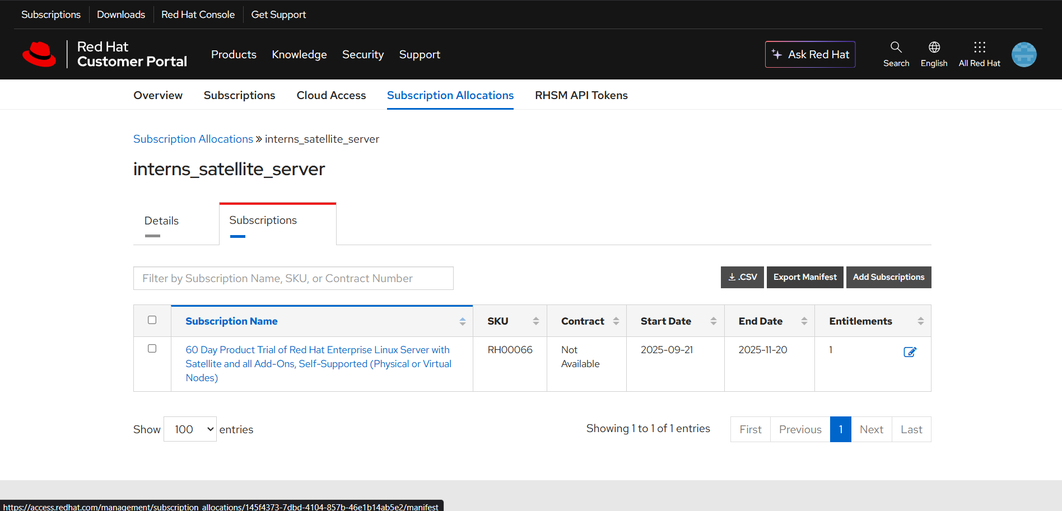
Use pscp.exe to send the file to satellite machine
pscp.exe C:\path\to\manifest_file.zip root@<satellite-server-ip>:/root/
[root@satellite-pd ~]# hammer subscription upload \
--file ~/manifest_file.zip \
--organization "My_Organization"

[root@satellite-pd ~]# hammer subscription list --organization "My_Organization"

